Product | : | DSL 305EU (Binatone)
Tested by | : | Lee Chee Soon
Hardware Version | : | V0.2
Firmware Version | : | V21.19.3
Test Dates | : | September 5, 2002 - September 11, 2002
Test Type | : | Functional Test
Test Objectives | : | To test the functionality of the modem.
Review By | :

1 Introduction
This test plan would specify the functionality of the ADSL modem and also provide future reference.

1.1 ADSL Modem Information
Modem Name/Project | DSL 305E/EU
Chipset and Manufacturer | Conexant CX82310
Firmware Version | 21.19.3
Other Features | Flash ROM upgradeable

1.2 Test Setup
CPE Configuration
Manufacturer | Aztech Systems Limited
Model | DSL 305E/EU
Chipset | Conexant CX82310
Line Driver/Receiver | -
Hardware Revision | V0.2
Firmware/Driver Revision | V21.19.3
Application S/W Revision | Web Management

Notes:
- Please use the common ADSL test system for all tests.

1.3 System Configuration
This section specifies other device available on the test system and also the OS platform for conducting the test. This can be used for debugging purposes.

System Configuration
System Name | Fujitsu Siemens Computers
Processors | Pentium III – 500Mhz
BIOS Version | W6183F1 V1.4B3 042400
System Memory | 128MB RDRAM
System Chipset | Intel (ICH 82801AA)
Hard drive | IBM 3.2GB
CD-ROM Drive | 12x CD-ROM
Video cards | On-board Graphics 810E Graphics Controller
Network Adapter | Linksys LNE100TX Fast Ethernet  Accton EN1207F Series PCI Fast Ethernet
Sound | On-board Intel 82801AA AC’97 Audio Controller
PCI slot for NIC | 3 PCI slots
Windows 95 OSR2.1 | Not Tested
Windows 98 | Not Tested
Windows 98 SE | Tested
Windows ME | Tested
Windows 2000 RTM | Tested
Windows XP Pro | Tested
Table 1.1: Target Systems Configuration

Network Setup

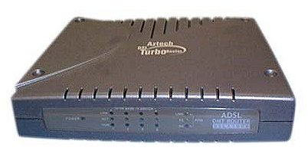
\ \
DSL305EU
Internet

Figure 1.1: Network Setup

1.4 Physical Layer and Hardware
Requirement |  | Result | Description
1.4.1 | Ethernet with Full Duplex | Pass  *10/100Mbps auto selection | The modem must have at least one 10BaseT Full Duplex Ethernet port.
1.4.2 | Auto-sensing Ethernet wiring | Not supported | The user may apply a crossed or a non-crossed Ethernet cable without notice.
1.4.3 | Auto-sensing ADSL wiring | Not supported | The user may apply a RJ-11 cable using either the pair on pins 3&4 or the pair on pins 2&5 for the ADSL signal without notice.
1.4.4 | Power On/Off Switch | Not Applicable | The modem must have a power on/off switch.
1.4.5 | Reset-to-Factory Default button | Pass | With a simple method it must be possible to reset the modem configuration to its factory default setting. The preferred method is to apply a power cycle while holding a reset button for at least 5 seconds.
1.4.6 | No Audible Noise | Pass | During normal operation, the level of audible noise level should be negligible and meet standards as for devices used in silent household environments.

1.5 Firmware Requirements
Requirement |  | Result | Description
1.5.1 | Dynamic Host Configuration Protocol (DHCP) Server | Pass | - Ensure that the DHCP Server option in the router modem is enable. Other option such as NAT can be disable for the testing purpose at this state.  - Set the TCP/IP Properties option in the Network applet under Control Panel windows with its <IP Address> tab set to “Obtain an IP address automatically” option.
1.5.2 | Network Address Translation (NAT) / Network Address Port Translation (NAPT) | Pass
1.5.3 | PAP and CHAP Authentication Test (RFC 2364 and RFC2516) | Pass  * Selection is made in Web Interface | - Connect to PPP server using PAP and CHAP authentication method.  - Make sure the PPP session is established and surf the Internet for a while.
1.5.4 | PVC Support | Pass
1.5.5 | Firmware updates | Pass | The modem firmware must be capable of being locally or remotely upgraded.
1.5.6 | Default IP address | Pass | The modem and its embedded servers use 10.0.0.2 as IP address by factory default setting.  The DHCP server is using the 10.0.0.X space by default.
1.5.7 | OAMLOOPBACK F4/F5 with End-to-End or Segment-to-Segment | Pass  *Tested on F5 End-to-End | Using Web Interface, under Diagnostic Test
1.5.8 | IPSec Pass-Through | Unable to test | IPSec Pass-Through with more than one VPN client active on the LAN. It is acceptable that the VPN Clients each connect to a different VPN Server with a distinct WAN IP address.
1.5.9 | Multiple IPSec Pass-Through | Unable to test | Multiple IPSec Client Pass-Through (more than one VPN client active) e.g. by applying dynamic port mapping of LAN port 500 to WAN ports 500, 501, 502, …

1.6 Management Requirements
Requirement |  | Result | Description
1.6.1 | PPP User ID and Password | Pass | The PPP User ID and Password will saved to the flash.
1.6.2 | Admin User ID and Password | Pass | The Admin User ID and Password must be clearly specified the access right.
1.6.3 | Utility for collecting traffic statistics | Pass | Check whether the Status shows the traffic statistics on the WAN interface, Ethernet interface, and USB interface or not.
1.6.4 | Remote Access Enable / Disable | Pass | The modem must allow the user to turn on/off all remote access.

1.7 Router Features Functionality Test
This test is used to specify the basic router features functionality available on the device under test, under the connected environment. To simplify the test environment and system setup for connectivity testing. We focus on the testing of these features using the test system under different OS environments.

Test Title |  | Win98SE | WinME | Win2000 | WinXP | Test Procedure
1.7.1 | DNS Queries | Pass | Pass | Pass | Pass | - Make sure all the protocols are able to connect to Internet.  - Use domain name to surf the net. E.g. http://www.yahoo.com/, http://www.microsoft.com/.
1.7.2 | Multiple PVC | Pass | Pass | Pass | Pass | The modem must be able to configure for multiple PVC.
1.7.3 | 10Mbps port connectivity test | Pass | Pass | Pass | Pass | Check the modem is able to transfer data using 10Mbps NIC.
1.7.4 | 100Mbps port connectivity test | Pass | Pass | Pass | Pass | Check the modem is able to transfer data using 100Mbps NIC.
1.7.5 | WAN connectivity test for DSL 305EU | Pass | Pass | Pass | Pass | Checks that all systems are able to surf the Internet when the modem is connected to a switch or hub.
1.7.6 | USB port connectivity test for DSL 305EU | Pass | Pass | Pass | Pass | - Check that when the USB cable is connected to the USB port of the system, the USB Link led is on (provide driver is correctly installed).  - Checks that when system configured to work under same workgroup. The Link/Act led is on and blinking when accessing information across systems.

1.8 USB Driver Installation/Uninstallation Test for DSL 305EU
Test Title |  | Win98SE | WinME | Win2000 | WinXP | Test Procedure
1.8.1 | Plug and Play Installation | Pass | Pass | Pass | Pass | At OS startup, verify that the USB gateway modem is auto detected and able to identify the correct driver. The installation should be able to recover from normal boot.
1.8.2 | Verify Control Panel | Pass | Pass | Pass | Pass | Under Add/Remove Programs, verify that whether the uninstallation program is available or not.
1.8.3 | Verify Device Manager | Pass | Pass | Pass | Pass | Verify that the USB gateway modem is properly installed or not.
1.8.4 | USB Port Independence | Pass | Pass | Pass | Pass | The USB gateway modem should be able to function when plug into one of the USB ports.
1.8.5 | Device compatibility | Pass | Pass | Pass | Pass | The USB gateway modem must be able to work with other USB device connected. E.g. USB Hub / Keyboard / Camera.
1.8.6 | Removing Drivers using the “Add/Remove Programs” | Pass | Pass | Pass | Pass | Remove the USB gateway modem via the “Add/Remove Programs”. Shut down, and manually unplug the USB gateway modem and power up the system. Make sure that the USB gateway modem does not appear in the Device Manager and all related file being removed.
1.8.7 | Plug and Plug repetition test | Pass | Pass | Pass | Pass | Plug in and out the USB gateway modem for 20 times. Make sure that the USB gateway modem is able to detect again by the system.
1.8.8 | USB port re-detection test | Pass | Pass | Pass | Pass | First, plug in the Ethernet cable and make a connection to the ISP, then unplug the Ethernet cable and plug in the USB cable. Make sure that the USB gateway modem does not recognize as ‘Unknown Device’.
1.8.9 | USB device redetection test | Pass | Pass | Pass | Pass | Interchanging the USB gateway modem with another USB device, example, Intel USB camera. Make sure that the reinstallation of driver is not needed.
1.9 Miscellaneous Configuration Test for DSL 305EU
Test Title |  | Win98SE | WinME | Win2000 | WinXP | Test Procedure
1.9.1 | WAN side HTTP server | Pass | Pass | Pass | Pass | When this option enable, user from other system can access the modem by entering the WAN address of the modem.
1.9.2 | FTP server | Pass | Pass | Pass | Pass | When this option enable, the FTP connection can be established from both the LAN and WAN sides.
1.9.3 | TFTP server | Pass | Pass | Pass | Pass | When this option enable, it can upgrade the image code with TFTP client application run either the LAN or WAN sides.
1.9.4 | DMZ | Not Tested | Not Tested | Not Tested | Not Tested | Refer to Appendix 3.6
1.9.5 | DHCP Relay | Not Tested | Not Tested | Not Tested | Not Tested
1.9.6 | IGMP Proxy | Not Tested | Not Tested | Not Tested | Not Tested | Refer to Appendix 3.7
1.9.7 | PPP reconnect on WAN access | Pass | Pass | Pass | Pass | Will trigger the modem to reconnect to ISP when user access the Internet.
1.9.8 | PPP Half bridge | Pass | Pass | Pass | Pass | When connected to ISP in this mode, must be able to surf the Internet.
1.9.9 | Virtual Server | Pass | Pass | Pass | Pass | Any local PCs must be able to be mapped to the UDP/TCP port on WAN side.
1.9.10 | Bridge Filtering | Not Tested | Not Tested | Not Tested | Not Tested

1.10 Protocol and Encapsulation Compatibility
Test Title |  | Win98SE | WinME | Win2000 | WinXP | Test Procedure
1.10.1 | PPP over ATM (RFC 2364) | Pass | Pass | Pass | Pass | No software is required because the firmware is able to connect automatically. Connect against SingNet Broadband.
1.10.2 | PPP over Ethernet (RFC 2516) | Pass | Pass | Pass | Pass | No software is required because the firmware is able to connect automatically. Connect against SingNet Broadband.
1.10.3 | Bridged Ethernet over ATM (RFC 1483) | Pass | Pass | Pass | Pass | Using WinPoET software. Connect against SingNet Broadband.
1.10.4 | Classical IP over ATM (RFC 1577) | Pass | Pass | Pass | Pass | Static IP therefore no software needed to connect. Connect against SingTel Magix.
1.10.5 | RFC 1483 Routed | Pass | Pass | Pass | Pass | Static IP therefore no software needed to connect. Connect against SingTel Magix.
1.10.6 | PPP Half bridge | Pass | Pass | Pass | Pass | When connected to ISP in this mode, must be able to surf the Internet. User must enter the user login name and password. Connect against SingNet Broadband.

1.11 Gaming test
Test Title |  | Win98SE | WinME | Win2000 | WinXP | Test Procedure
1.11.1 | StarCraft | Not Tested | Not Tested | Not Tested | Not Tested | The gaming can be conducted with Internet Players
1.11.2 | Half-Life | Pass | Pass | Pass | Pass | The gaming can be conducted with Internet Players

For game tests, the TEST would failed if:
- The gaming party using ADSL disconnect repeatedly
- One of the gaming parties cannot connect to same game server

Note: The test is done in PPPoA Encapsulation protocol, router mode.

1.12 Netmeeting Test
Test Title |  | Win98SE | WinME | Win2000 | WinXP | Test Procedure
1.12.1 | PPP over ATM (RFC 2364) | Pass | Pass | Pass | Pass | Setup the Netmeeting on local PC, and try to make a call to remote PC. See whether the connection can be established, or local PC is able to view remote PC or not. Connect against SingNet Broadband.
1.12.2 | PPP over Ethernet (RFC 2516) | Pass | Pass | Pass | Pass | Setup the Netmeeting on local PC, and try to make a call to remote PC. See whether the connection can be established, or local PC is able to view remote PC or not. Connect against SingNet Broadband.
1.12.3 | Bridged Ethernet over ATM (RFC 1483) | Pass | Pass | Pass | Pass | Setup the Netmeeting on local PC, and try to make a call to remote PC. See whether the connection can be established, or local PC is able to view remote PC or not. Connect against SingNet Broadband. Using WinPoET to dial to ISP.
1.12.4 | Classical IP over ATM (RFC 1577) | Pass | Pass | Pass | Pass | Setup the Netmeeting on local PC, and try to make a call to remote PC. See whether the connection can be established, or local PC is able to view remote PC or not. Connect against SingTel Magix.
1.12.5 | RFC 1483 Routed | Pass | Pass | Pass | Pass | Setup the Netmeeting on local PC, and try to make a call to remote PC. See whether the connection can be established, or local PC is able to view remote PC or not. Connect against SingTel Magix.
1.12.6 | PPP Half Bridge | Pass | Pass | Pass | Pass | Setup the Netmeeting on local PC, and try to make a call to remote PC. See whether the connection can be established, or local PC is able to view remote PC or not. Connect against SingNet Broadband.

For Netmeeting tests, the TEST would fail if:
- The connection can’t be established at all

1.13 Application Test.
Test Title |  | Win98SE | WinME | Win2000 | WinXP | Test Procedure
1.13.1 | Netmeeting  Refer to #1 | Pass | Pass | Pass | Pass | Setup the Netmeeting on local PC, and try to make a call to remote PC. See whether the connection can be established, or local PC is able to view remote PC or not.
1.13.2 | ICQ  Refer to #2 | Pass | Pass | Pass | Pass | Must be able to log in to ICQ server.
1.13.3 | mIRC  Refer to #3 | Pass | Pass | Pass | Pass | Must be able to join in to a chat room.
1.13.4 | Microsoft Messenger  Refer to #2 | Pass | Pass | Pass | Pass | Must be able to log in to Microsoft Messenger server.
1.13.5 | FTP download  Refer to #3 | Pass | Pass | Pass | Pass | Must be able to log in to local and oversea FTP server and download / upload files.
1.13.6 | Http download  Refer to #3 | Pass | Pass | Pass | Pass | Must be able to download files from local and oversea websites.
1.13.7 | Video Streaming  Refer to #3 | Pass | Pass | Pass | Pass | Must be able to watch video streaming from local and oversea websites.  Refer to #4

For the above tests, the TEST would fail if:
- The connection can’t be established at all
- Cannot receive and sent files (for Netmeeting, ICQ, mIRC, Microsoft Messenger and FTP)
- Cannot receive and sent message (for Netmeeting, ICQ, mIRC, Microsoft Messenger)

Note:
#1. This test will be done differently in WinXP. Refer to Appendix 3.5.

#2. These tests are done in PPP half-bridge and transparent bridge mode (single user). In router mode, client program can log into server but may not be able to sent and received files. For ICQ client in router mode, enable firewall option in the ICQ client to sent and received files.

#3. These tests are done in all modes.

#4. For this test, certain websites need video plug-in to view the video streaming. In this test we use Microsoft Media Player as out basis. Other Video plug-in may constitute to a different result.

2 Performance Test

2.1 FTP & Audio/Video Streaming Test on PPP over ATM (RFC 2364) against
SingNet Broadband

- FTP – using WS_FTP LE version 5.08
- Audio/Video streaming - using Windows Media Player v7.0

Test Title | Win98SE |  | Test Procedure
Test Title | Ethernet | USB | Test Procedure
FTP test | PASS  Upload speed : 25.9 KB/S  Download speed : 19.47 KB/S  Subscribed Bandwidth: 512 Kbps Downstream, 256Kbps Upstream | PASS  Upload speed : 21.3 KB/S  Download speed : 17.43 KB/S  Subscribed Bandwidth: 512 Kbps Downstream, 256Kbps Upstream | - Go to oversea website : www.download.com, and download a >20MB file.  - Go to local website : ftp.aztech.com.sg, and upload a >20MB file.
Streaming Audio and Video | PASS  Tested for : 10 mins  Downstream : 3488 Kbps Upstream : 448 Kbps  Actual rate : 14.02  Transmission protocol : Unicast TCP  Bandwidth : 203 Kbps  Total received packet : 6440  Total bad packet : 0 | PASS  Tested for : 10 mins  Downstream : 3488 Kbps Upstream : 448 Kbps  Actual rate : 14.30  Transmission protocol : Unicast TCP  Bandwidth : 204 Kbps  Total received packet : 6540  Total bad packet : 0 | Go to local website: www.channelnewsasia.com for this test.

Test Title | WinME |  | Test Procedure
Test Title | Ethernet | USB | Test Procedure
FTP test | PASS  Upload speed : 26.52 KB/S  Download speed : 11.7 KB/S  Subscribed Bandwidth: 512 Kbps Downstream, 256Kbps Upstream | PASS  Upload speed : 21.3 KB/S  Download speed : 17.43 KB/S  Subscribed Bandwidth: 512 Kbps Downstream, 256Kbps Upstream | - Go to oversea website : www.download.com, and download a >20MB file.  - Go to local website : ftp.aztech.com.sg, and upload a >20MB file.
Streaming Audio and Video | PASS  Tested for : 10 mins  Downstream : 3488 Kbps Upstream : 448 Kbps  Actual rate : 14.1  Transmission protocol : Unicast TCP  Bandwidth : 204 Kbps  Total received packet : 6413  Total bad packet : 0 | PASS  Tested for : 10 mins  Downstream : 3488 Kbps Upstream : 448 Kbps  Actual rate : 14.36  Transmission protocol : Unicast TCP  Bandwidth : 204 Kbps  Total received packet : 6212  Total bad packet : 0 | Go to local website: www.channelnewsasia.com for this test.

Test Title | Win2000 |  | Test Procedure
Test Title | Ethernet | USB | Test Procedure
FTP test | PASS  Upload speed : 26.52 KB/S  Download speed : 11.5 KB/S  Subscribed Bandwidth: 512 Kbps Downstream, 256Kbps Upstream | PASS  Upload speed : 27.95 KB/S  Download speed : 11.7 KB/S  Subscribed Bandwidth: 512 Kbps Downstream, 256Kbps Upstream | - Go to oversea website : www.download.com, and download a >20MB file.  - Go to local website : ftp.aztech.com.sg, and upload a >20MB file.
Streaming Audio and Video | PASS  Tested for : 10 mins  Downstream : 3488 Kbps Upstream : 448 Kbps  Actual rate : 14.52  Transmission protocol : Unicast TCP  Bandwidth : 204 Kbps  Total received packet : 6218  Total bad packet : 0 | PASS  Tested for : 10 mins  Downstream : 3488 Kbps Upstream : 448 Kbps  Actual rate : 14.48  Transmission protocol : Unicast TCP  Bandwidth : 204 Kbps  Total received packet : 6208  Total bad packet : 0 | Go to local website: www.channelnewsasia.com for this test.

Test Title | WinXP |  | Test Procedure
Test Title | Ethernet | USB | Test Procedure
FTP test | PASS  Upload speed : 24.34 KB/S  Download speed : 11.08 KB/S  Subscribed Bandwidth: 512 Kbps Downstream, 256Kbps Upstream | PASS  Upload speed : 23.84 KB/S  Download speed : 12.46 KB/S  Subscribed Bandwidth: 512 Kbps Downstream, 256Kbps Upstream | - Go to oversea website : www.download.com, and download a >20MB file.  - Go to local website : ftp.aztech.com.sg, and upload a >20MB file.
Streaming Audio and Video | PASS  Tested for : 10 mins  Downstream : 3488 Kbps Upstream : 448 Kbps  Actual rate : 14.06  Transmission protocol : Unicast TCP  Bandwidth : 204 Kbps  Total received packet : 6470  Total bad packet : 0 | PASS  Tested for : 10 mins  Downstream : 3488 Kbps Upstream : 448 Kbps  Actual rate : 14.61  Transmission protocol : Unicast TCP  Bandwidth : 204 Kbps  Total received packet : 6208  Total bad packet : 0 | Go to local website: www.channelnewsasia.com for this test.

2.2 FTP & Audio/Video Streaming Test on PPP over Ethernet (RFC 2364) against
SingNet Broadband

- FTP – using WS_FTP LE version 5.08
- Audio/Video streaming - using Windows Media Player v7.0

Test Title | Win98SE |  | Test Procedure
Test Title | Ethernet | USB | Test Procedure
FTP test | PASS  Upload speed : 27.2 KB/S  Download speed : 9.94 KB/S  Subscribed Bandwidth: 512 Kbps Downstream, 256Kbps Upstream | PASS  Upload speed : 22.3 KB/S  Download speed : 10.43 KB/S  Subscribed Bandwidth: 512 Kbps Downstream, 256Kbps Upstream | - Go to oversea website : www.download.com, and download a >20MB file.  - Go to local website : ftp.aztech.com.sg, and upload a >20MB file.
Streaming Audio and Video | PASS  Tested for : 10 mins  Downstream : 3488 Kbps Upstream : 448 Kbps  Actual rate : 14.5  Transmission protocol : Unicast TCP  Bandwidth : 203 Kbps  Total received packet : 6376  Total bad packet : 0 | PASS  Tested for : 10 mins  Downstream : 3488 Kbps Upstream : 448 Kbps  Actual rate : 14.33  Transmission protocol : Unicast TCP  Bandwidth : 204 Kbps  Total received packet : 6440  Total bad packet : 0 | Go to local website: www.channelnewsasia.com for this test.

Test Title | WinME |  | Test Procedure
Test Title | Ethernet | USB | Test Procedure
FTP test | PASS  Upload speed : 25.52 KB/S  Download speed : 11.7 KB/S  Subscribed Bandwidth: 512 Kbps Downstream, 256Kbps Upstream | PASS  Upload speed : 22.3 KB/S  Download speed : 13.43 KB/S  Subscribed Bandwidth: 512 Kbps Downstream, 256Kbps Upstream | - Go to oversea website : www.download.com, and download a >20MB file.  - Go to local website : ftp.aztech.com.sg, and upload a >20MB file.
Streaming Audio and Video | PASS  Tested for : 10 mins  Downstream : 3488 Kbps Upstream : 448 Kbps  Actual rate : 14.1  Transmission protocol : Unicast TCP  Bandwidth : 204 Kbps  Total received packet : 6424  Total bad packet : 0 | PASS  Tested for : 10 mins  Downstream : 3488 Kbps Upstream : 448 Kbps  Actual rate : 14.36  Transmission protocol : Unicast TCP  Bandwidth : 204 Kbps  Total received packet : 6219  Total bad packet : 0 | Go to local website: www.channelnewsasia.com for this test.

Test Title | Win2000 |  | Test Procedure
Test Title | Ethernet | USB | Test Procedure
FTP test | PASS  Upload speed : 25.52 KB/S  Download speed : 11.2 KB/S  Subscribed Bandwidth: 512 Kbps Downstream, 256Kbps Upstream | PASS  Upload speed : 25.95 KB/S  Download speed : 11.3 KB/S  Subscribed Bandwidth: 512 Kbps Downstream, 256Kbps Upstream | - Go to oversea website : www.download.com, and download a >20MB file.  - Go to local website : ftp.aztech.com.sg, and upload a >20MB file.
Streaming Audio and Video | PASS  Tested for : 10 mins  Downstream : 3488 Kbps Upstream : 448 Kbps  Actual rate : 14.62  Transmission protocol : Unicast TCP  Bandwidth : 204 Kbps  Total received packet : 6418  Total bad packet : 0 | PASS  Tested for : 10 mins  Downstream : 3488 Kbps Upstream : 448 Kbps  Actual rate : 14.50  Transmission protocol : Unicast TCP  Bandwidth : 204 Kbps  Total received packet : 6408  Total bad packet : 0 | Go to local website: www.channelnewsasia.com for this test.

Test Title | WinXP |  | Test Procedure
Test Title | Ethernet | USB | Test Procedure
FTP test | PASS  Upload speed : 23.34 KB/S  Download speed : 10.08 KB/S  Subscribed Bandwidth: 512 Kbps Downstream, 256Kbps Upstream | PASS  Upload speed : 24.84 KB/S  Download speed : 12.46 KB/S  Subscribed Bandwidth: 512 Kbps Downstream, 256Kbps Upstream | - Go to oversea website : www.download.com, and download a >20MB file.  - Go to local website : ftp.aztech.com.sg, and upload a >20MB file.
Streaming Audio and Video | PASS  Tested for : 10 mins  Downstream : 3488 Kbps Upstream : 448 Kbps  Actual rate : 14.36  Transmission protocol : Unicast TCP  Bandwidth : 204 Kbps  Total received packet : 6870  Total bad packet : 0 | PASS  Tested for : 10 mins  Downstream : 3488 Kbps Upstream : 448 Kbps  Actual rate : 14.63  Transmission protocol : Unicast TCP  Bandwidth : 204 Kbps  Total received packet : 6408  Total bad packet : 0 | Go to local website: www.channelnewsasia.com for this test.

2.3 FTP & Audio/Video Streaming Test on Bridged Ethernet (RFC 2364/1483)
against SingNet Broadband (using WinPoET)

- FTP – using WS_FTP LE version 5.08
- Audio/Video streaming - using Windows Media Player v7.0

Test Title | Win98SE |  | Test Procedure
Test Title | Ethernet | USB | Test Procedure
FTP test | PASS  Upload speed : 24.2 KB/S  Download speed : 10.94 KB/S  Subscribed Bandwidth: 512 Kbps Downstream, 256Kbps Upstream | PASS  Upload speed : 23.3 KB/S  Download speed : 10.23 KB/S  Subscribed Bandwidth: 512 Kbps Downstream, 256Kbps Upstream | - Go to oversea website : www.download.com, and download a >20MB file.  - Go to local website : ftp.aztech.com.sg, and upload a >20MB file.
Streaming Audio and Video | PASS  Tested for : 10 mins  Downstream : 3488 Kbps Upstream : 448 Kbps  Actual rate : 14.53  Transmission protocol : Unicast TCP  Bandwidth : 203 Kbps  Total received packet : 6276  Total bad packet : 0 | PASS  Tested for : 10 mins  Downstream : 3488 Kbps Upstream : 448 Kbps  Actual rate : 14.33  Transmission protocol : Unicast TCP  Bandwidth : 204 Kbps  Total received packet : 6240  Total bad packet : 0 | Go to local website: www.channelnewsasia.com for this test.

Test Title | WinME |  | Test Procedure
Test Title | Ethernet | USB | Test Procedure
FTP test | PASS  Upload speed : 25.52 KB/S  Download speed : 10.7 KB/S  Subscribed Bandwidth: 512 Kbps Downstream, 256Kbps Upstream | PASS  Upload speed : 22.3 KB/S  Download speed : 11.43 KB/S  Subscribed Bandwidth: 512 Kbps Downstream, 256Kbps Upstream | - Go to oversea website : www.download.com, and download a >20MB file.  - Go to local website : ftp.aztech.com.sg, and upload a >20MB file.
Streaming Audio and Video | PASS  Tested for : 10 mins  Downstream : 3488 Kbps Upstream : 448 Kbps  Actual rate : 14.12  Transmission protocol : Unicast TCP  Bandwidth : 204 Kbps  Total received packet : 6434  Total bad packet : 0 | PASS  Tested for : 10 mins  Downstream : 3488 Kbps Upstream : 448 Kbps  Actual rate : 14.16  Transmission protocol : Unicast TCP  Bandwidth : 204 Kbps  Total received packet : 6229  Total bad packet : 0 | Go to local website: www.channelnewsasia.com for this test.

Test Title | Win2000 |  | Test Procedure
Test Title | Ethernet | USB | Test Procedure
FTP test | PASS  Upload speed : 23.52 KB/S  Download speed : 13.2 KB/S  Subscribed Bandwidth: 512 Kbps Downstream, 256Kbps Upstream | PASS  Upload speed : 23.95 KB/S  Download speed : 12.3 KB/S  Subscribed Bandwidth: 512 Kbps Downstream, 256Kbps Upstream | - Go to oversea website : www.download.com, and download a >20MB file.  - Go to local website : ftp.aztech.com.sg, and upload a >20MB file.
Streaming Audio and Video | PASS  Tested for : 10 mins  Downstream : 3488 Kbps Upstream : 448 Kbps  Actual rate : 15.62  Transmission protocol : Unicast TCP  Bandwidth : 204 Kbps  Total received packet : 6518  Total bad packet : 0 | PASS  Tested for : 10 mins  Downstream : 3488 Kbps Upstream : 448 Kbps  Actual rate : 14.54  Transmission protocol : Unicast TCP  Bandwidth : 204 Kbps  Total received packet : 6428  Total bad packet : 0 | Go to local website: www.channelnewsasia.com for this test.

Test Title | WinXP |  | Test Procedure
Test Title | Ethernet | USB | Test Procedure
FTP test | PASS  Upload speed : 22.34 KB/S  Download speed : 16.08 KB/S  Subscribed Bandwidth: 512 Kbps Downstream, 256Kbps Upstream | PASS  Upload speed : 22.84 KB/S  Download speed : 12.47 KB/S  Subscribed Bandwidth: 512 Kbps Downstream, 256Kbps Upstream | - Go to oversea website : www.download.com, and download a >20MB file.  - Go to local website : ftp.aztech.com.sg, and upload a >20MB file.
Streaming Audio and Video | PASS  Tested for : 10 mins  Downstream : 3488 Kbps Upstream : 448 Kbps  Actual rate : 14.32  Transmission protocol : Unicast TCP  Bandwidth : 204 Kbps  Total received packet : 6770  Total bad packet : 0 | PASS  Tested for : 10 mins  Downstream : 3488 Kbps Upstream : 448 Kbps  Actual rate : 14.23  Transmission protocol : Unicast TCP  Bandwidth : 204 Kbps  Total received packet : 6608  Total bad packet : 0 | Go to local website: www.channelnewsasia.com for this test.

2.4 FTP & Audio/Video Streaming Test on Classical over ATM (RFC 2225/1577)
against Singtel Magix

- FTP – using WS_FTP LE version 5.08
- Audio/Video streaming - using Windows Media Player v7.0

Test Title | Win98SE |  | Test Procedure
Test Title | Ethernet | USB | Test Procedure
FTP test | PASS  Upload speed : 21.2 KB/S  Download speed : 10.64 KB/S  Subscribed Bandwidth: 512 Kbps Downstream, 256Kbps Upstream | PASS  Upload speed : 22.3 KB/S  Download speed : 11.23 KB/S  Subscribed Bandwidth: 512 Kbps Downstream, 256Kbps Upstream | - Go to oversea website : www.download.com, and download a >20MB file.  - Go to local website : ftp.aztech.com.sg, and upload a >20MB file.
Streaming Audio and Video | PASS  Tested for : 10 mins  Downstream : 3488 Kbps Upstream : 448 Kbps  Actual rate : 14.63  Transmission protocol : Unicast TCP  Bandwidth : 203 Kbps  Total received packet : 6476  Total bad packet : 0 | PASS  Tested for : 10 mins  Downstream : 3488 Kbps Upstream : 448 Kbps  Actual rate : 14.23  Transmission protocol : Unicast TCP  Bandwidth : 204 Kbps  Total received packet : 6440  Total bad packet : 0 | Go to local website: www.channelnewsasia.com for this test.

Test Title | WinME |  | Test Procedure
Test Title | Ethernet | USB | Test Procedure
FTP test | PASS  Upload speed : 24.52 KB/S  Download speed : 11.7 KB/S  Subscribed Bandwidth: 512 Kbps Downstream, 256Kbps Upstream | PASS  Upload speed : 25.3 KB/S  Download speed : 12.43 KB/S  Subscribed Bandwidth: 512 Kbps Downstream, 256Kbps Upstream | - Go to oversea website : www.download.com, and download a >20MB file.  - Go to local website : ftp.aztech.com.sg, and upload a >20MB file.
Streaming Audio and Video | PASS  Tested for : 10 mins  Downstream : 3488 Kbps Upstream : 448 Kbps  Actual rate : 14.11  Transmission protocol : Unicast TCP  Bandwidth : 204 Kbps  Total received packet : 6424  Total bad packet : 0 | PASS  Tested for : 10 mins  Downstream : 3488 Kbps Upstream : 448 Kbps  Actual rate : 14.12  Transmission protocol : Unicast TCP  Bandwidth : 204 Kbps  Total received packet : 6329  Total bad packet : 0 | Go to local website: www.channelnewsasia.com for this test.

Test Title | Win2000 |  | Test Procedure
Test Title | Ethernet | USB | Test Procedure
FTP test | PASS  Upload speed : 22.52 KB/S  Download speed : 12.2 KB/S  Subscribed Bandwidth: 512 Kbps Downstream, 256Kbps Upstream | PASS  Upload speed : 22.95 KB/S  Download speed : 11.3 KB/S  Subscribed Bandwidth: 512 Kbps Downstream, 256Kbps Upstream | - Go to oversea website : www.download.com, and download a >20MB file.  - Go to local website : ftp.aztech.com.sg, and upload a >20MB file.
Streaming Audio and Video | PASS  Tested for : 10 mins  Downstream : 3488 Kbps Upstream : 448 Kbps  Actual rate : 15.42  Transmission protocol : Unicast TCP  Bandwidth : 204 Kbps  Total received packet : 6318  Total bad packet : 0 | PASS  Tested for : 10 mins  Downstream : 3488 Kbps Upstream : 448 Kbps  Actual rate : 15.54  Transmission protocol : Unicast TCP  Bandwidth : 204 Kbps  Total received packet : 6328  Total bad packet : 0 | Go to local website: www.channelnewsasia.com for this test.

Test Title | WinXP |  | Test Procedure
Test Title | Ethernet | USB | Test Procedure
FTP test | PASS  Upload speed : 21.34 KB/S  Download speed : 15.08 KB/S  Subscribed Bandwidth: 512 Kbps Downstream, 256Kbps Upstream | PASS  Upload speed : 21.84 KB/S  Download speed : 13.47 KB/S  Subscribed Bandwidth: 512 Kbps Downstream, 256Kbps Upstream | - Go to oversea website : www.download.com, and download a >20MB file.  - Go to local website : ftp.aztech.com.sg, and upload a >20MB file.
Streaming Audio and Video | PASS  Tested for : 10 mins  Downstream : 3488 Kbps Upstream : 448 Kbps  Actual rate : 14.36  Transmission protocol : Unicast TCP  Bandwidth : 204 Kbps  Total received packet : 6870  Total bad packet : 0 | PASS  Tested for : 10 mins  Downstream : 3488 Kbps Upstream : 448 Kbps  Actual rate : 14.63  Transmission protocol : Unicast TCP  Bandwidth : 204 Kbps  Total received packet : 6708  Total bad packet : 0 | Go to local website: www.channelnewsasia.com for this test.

2.5 FTP & Audio/Video Streaming Test on RFC 1483 Routed against Singtel Magix

- FTP – using WS_FTP LE version 5.08
- Audio/Video streaming - using Windows Media Player v7.0

Test Title | Win98SE |  | Test Procedure
Test Title | Ethernet | USB | Test Procedure
FTP test | PASS  Upload speed : 22.2 KB/S  Download speed : 11.64 KB/S  Subscribed Bandwidth: 512 Kbps Downstream, 256Kbps Upstream | PASS  Upload speed : 22.3 KB/S  Download speed : 12.23 KB/S  Subscribed Bandwidth: 512 Kbps Downstream, 256Kbps Upstream | - Go to oversea website : www.download.com, and download a >20MB file.  - Go to local website : ftp.aztech.com.sg, and upload a >20MB file.
Streaming Audio and Video | PASS  Tested for : 10 mins  Downstream : 3488 Kbps Upstream : 448 Kbps  Actual rate : 14.73  Transmission protocol : Unicast TCP  Bandwidth : 203 Kbps  Total received packet : 6436  Total bad packet : 0 | PASS  Tested for : 10 mins  Downstream : 3488 Kbps Upstream : 448 Kbps  Actual rate : 14.33  Transmission protocol : Unicast TCP  Bandwidth : 204 Kbps  Total received packet : 6340  Total bad packet : 0 | Go to local website: www.channelnewsasia.com for this test.

Test Title | WinME |  | Test Procedure
Test Title | Ethernet | USB | Test Procedure
FTP test | PASS  Upload speed : 24.32 KB/S  Download speed : 12.7 KB/S  Subscribed Bandwidth: 512 Kbps Downstream, 256Kbps Upstream | PASS  Upload speed : 25.2 KB/S  Download speed : 11.43 KB/S  Subscribed Bandwidth: 512 Kbps Downstream, 256Kbps Upstream | - Go to oversea website : www.download.com, and download a >20MB file.  - Go to local website : ftp.aztech.com.sg, and upload a >20MB file.
Streaming Audio and Video | PASS  Tested for : 10 mins  Downstream : 3488 Kbps Upstream : 448 Kbps  Actual rate : 14.31  Transmission protocol : Unicast TCP  Bandwidth : 204 Kbps  Total received packet : 6434  Total bad packet : 0 | PASS  Tested for : 10 mins  Downstream : 3488 Kbps Upstream : 448 Kbps  Actual rate : 14.32  Transmission protocol : Unicast TCP  Bandwidth : 204 Kbps  Total received packet : 6429  Total bad packet : 0 | Go to local website: www.channelnewsasia.com for this test.

Test Title | Win2000 |  | Test Procedure
Test Title | Ethernet | USB | Test Procedure
FTP test | PASS  Upload speed : 22.22 KB/S  Download speed : 13.2 KB/S  Subscribed Bandwidth: 512 Kbps Downstream, 256Kbps Upstream | PASS  Upload speed : 22.45 KB/S  Download speed : 12.3 KB/S  Subscribed Bandwidth: 512 Kbps Downstream, 256Kbps Upstream | - Go to oversea website : www.download.com, and download a >20MB file.  - Go to local website : ftp.aztech.com.sg, and upload a >20MB file.
Streaming Audio and Video | PASS  Tested for : 10 mins  Downstream : 3488 Kbps Upstream : 448 Kbps  Actual rate : 14.42  Transmission protocol : Unicast TCP  Bandwidth : 204 Kbps  Total received packet : 6418  Total bad packet : 0 | PASS  Tested for : 10 mins  Downstream : 3488 Kbps Upstream : 448 Kbps  Actual rate : 14.54  Transmission protocol : Unicast TCP  Bandwidth : 204 Kbps  Total received packet : 6358  Total bad packet : 0 | Go to local website: www.channelnewsasia.com for this test.

Test Title | WinXP |  | Test Procedure
Test Title | Ethernet | USB | Test Procedure
FTP test | PASS  Upload speed : 22.34 KB/S  Download speed : 15.58 KB/S  Subscribed Bandwidth: 512 Kbps Downstream, 256Kbps Upstream | PASS  Upload speed : 23.84 KB/S  Download speed : 15.47 KB/S  Subscribed Bandwidth: 512 Kbps Downstream, 256Kbps Upstream | - Go to oversea website : www.download.com, and download a >20MB file.  - Go to local website : ftp.aztech.com.sg, and upload a >20MB file.
Streaming Audio and Video | PASS  Tested for : 10 mins  Downstream : 3488 Kbps Upstream : 448 Kbps  Actual rate : 14.56  Transmission protocol : Unicast TCP  Bandwidth : 204 Kbps  Total received packet : 6872  Total bad packet : 0 | PASS  Tested for : 10 mins  Downstream : 3488 Kbps Upstream : 448 Kbps  Actual rate : 14.93  Transmission protocol : Unicast TCP  Bandwidth : 204 Kbps  Total received packet : 6738  Total bad packet : 0 | Go to local website: www.channelnewsasia.com for this test.

2.7 Feature Check List

Summary of protocols supported by the device under test.

# | Feature | Support | Remarks
1) | RFC 2684/1483 | 
2) | RFC 2225/1577 | 
3) | RFC 2364 | 
4) | RFC 2516 | 
6) | OAM F4, F5 Loopback | 
7) | Bit Swapping | 
8) | ADSL Mode Selection :  - Autosense  - G.Lite Only  - ANSI Only  - G.DMT Only
8) |  | 
8) |  | 
8) |  | 
8) |  | 

Notes :

- 'Tick' if supported
- 'Cross' if not supported
- 'NA' if not applicable
- 'Future' if to be supported in future, and indicate timeframe in Remarks column

3 Appendix

3.1 Technology of PPP Half-Bridge mode

Conexant has come out with this technology of PPP Half-Bridge mode. Take a look at the following figures:

Common ADSL Modem
ISP Server
Internet
Using Dialer to dial to ISP. Some common dialer like WinPoET, Microsoft Dial-up, etc.

Figure 3.1.1 – Common way to dial to ISP

As can see from the above figure 3.1.1, the PC initiates the dialing process. PC must install certain dialer such as WinPoET or Microsoft Dial-up to initiates the dialing process.

DSL305EU ADSL Modem
ISP Server
Internet
No need dialer as dialing is initiated at ADSL modem. Just save User ID and Password in modem.

Figure 3.1.2 – PPP Half-bridge modem

In figure 3.1.2, the DSL305EU ADSL initiates the dialing process. PC does not require any dialer software. Open up web browser and save the User ID and Password in the modem. Once User ID and Password is saved, the modem will automatically connect to ISP. Click ‘Disconnect’ in the ‘Connection Status’ to disconnect from ISP. (refer to Manual on how to access the modem with web browser)

Note: Only single user can use PPP half-bridge.

The Advantages and Disadvantages of PPP Half-bridge.
Advantages
- No installation of software is required thus saving cost.
Disadvantages
- PPP half-bridge mode will take some time for the WAN IP address to transfer to the PC (about 1 min). User will sometime experience ‘Page cannot display’ on the browser (when the process of connecting to ISP).

3.2 Screen Shots
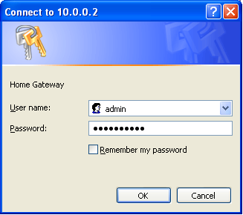

Figure 3.2.1 Login Window Popup
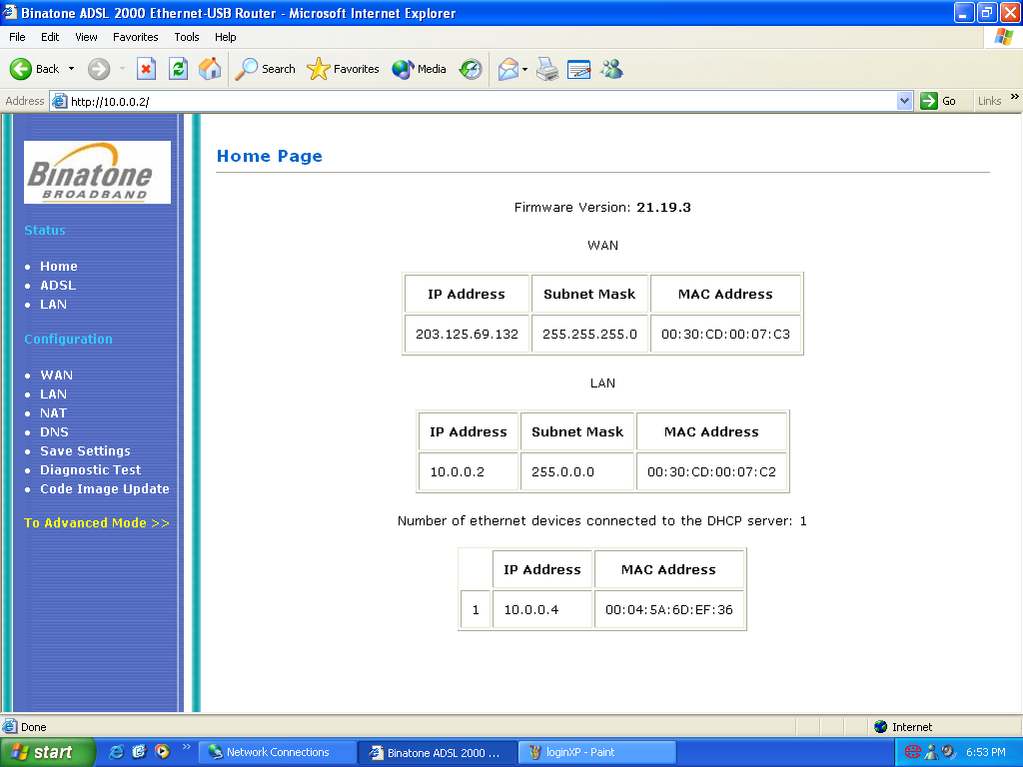

Figure 3.2.2 Easy Mode page

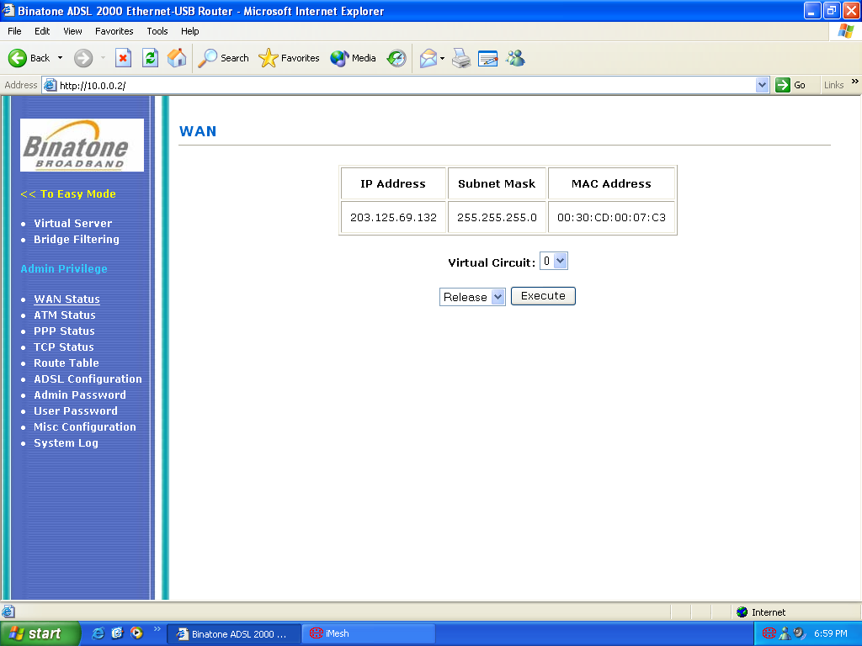
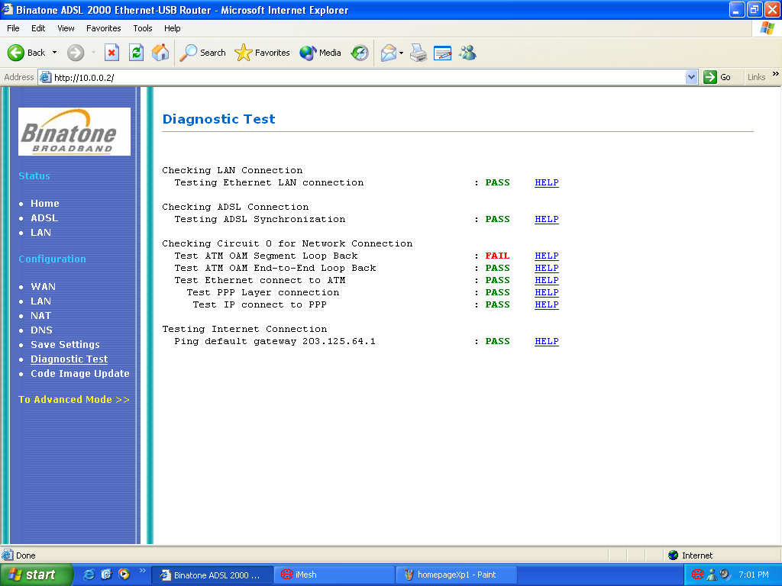
Figure 3.2.3 Advance Mode Page

Figure 2.2.4 Diagnostic Test Page

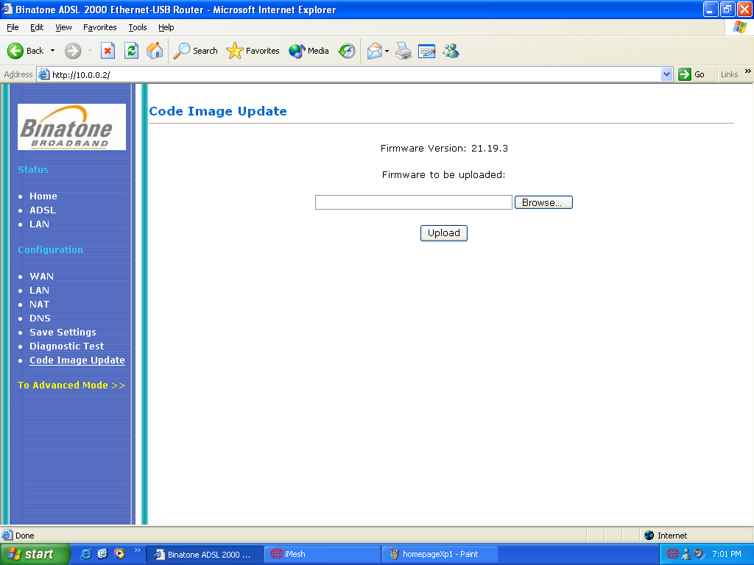
Figure 3.2.5 Firmware Update Page

3.3 Updating Firmware

- To update the firmware, click on the link, ‘Firmware Update’ to go to the Firmware Update page (Figure 3.2.5)
- Click on the Browse button to select the ‘firmware.dlf’ file.
- Click Upload button to upload the firmware file to the flash memory.
- The file will upload and restart the modem to upgrade/downgrade firmware of the modem.

3.4 Gaming test

This section tests the modem whether is it able to connect to Game servers or play Internet Game. The game running on this modem is Half-life with latest update of version 1110. The test is conduct in this way:

- Connect to ISP. (SingNet Broadband)
- Run Half-life.
- Go to Multi-player and select Internet.
- Select any server. It is advisable to connect to a high-speed low latency server.
- Play the game.

The test results are shown on section 1.8.

3.5 Netmeeting test

This section tests the modem whether is it able to run the Netmeeting and stream video and voice data to another remote user.
Internet
DSL 305EU
Netmeeting 1
Netmeeting 2

Figure 3.5.1 Netmeeting

Test done under Win98 SE, Win ME and Win 2000

- Connect to ISP. (SingNet Broadband)
- Start Microsoft Messenger. You may need to register a hotmail account.
- Using Microsoft Messenger, start a Netmeeting session with another party.
- Check whether the other party can able to communicate with you.
- Check the Video streaming and Voice streaming.

Test done under Win XP

- Connect to ISP. (SingNet Broadband)
- Start and Configure Netmeeting session.
- If you are able to log in to the Microsoft Internet Directory Server, you may find another party to have a Netmeeting session with you. Please note that Microsoft Internet Directory is not maintained, you may need to find other ILS server. Please go to www.meetingbywire.com/NetMeeting101.htm for more information.
- If not you have to key in the WAN IP address of the other party in the ‘Address field’.
- Check whether the other party can able to communicate with you.
- Check the Video streaming and Voice streaming.

The test results are shown on section 1.9.

3.6 DMZ

In computer networks, a DMZ (demilitarized zone) is a computer host or small network inserted as a "neutral zone" between a company's private network and the outside public network. It prevents outside users from getting direct access to a server that has company data. (The term comes from the geographic buffer zone that was set up between North Korea and South Korea following the UN "police action" in the early 1950s.) A DMZ is an optional and more secure approach to a firewall and effectively acts as a proxy server as well.

In a typical DMZ configuration for a small company, a separate computer (or host in network terms) receives requests from users within the private network for access to Web sites or other companies accessible on the public network. The DMZ host then initiates sessions for these requests on the public network. However, the DMZ host is not able to initiate a session back into the private network. It can only forward packets that have already been requested.

Users of the public network outside the company can access only the DMZ host. The DMZ may typically also have the company's Web pages so these could be served to the outside world. However, the DMZ provides access to no other company data. In the event that an outside user penetrated the DMZ host's security, the Web pages might be corrupted but no other company information would be exposed. Cisco, the leading maker of routers, is one company that sells products designed for setting up a DMZ.

Reference: Whatis.com, 2002. http://searchwebservices.techtarget.com/sDefinition/0,,sid26_gci213891,00.html
(Accessed 24/09/2002)

3.7 IGMP

The Internet Group Management Protocol (IGMP) is an Internet protocol that provides a way for an Internet computer to report its multicast group membership to adjacent routers. Multicasting allows one computer on the Internet to send content to multiple other computers that have identified themselves as interested in receiving the originating computer's content. Multicasting can be used for such applications as updating the address books of mobile computer users in the field, sending out company newsletters to a distribution list, and "broadcasting" high-bandwidth programs of streaming media to an audience that has "tuned in" by setting up a multicast group membership.

Using the Open Systems Interconnection (OSI) communication model, IGMP is part of the Network layer. IGMP is formally described in the Internet Engineering Task Force (IETF) Request for Comments (RFC) 2236.

Reference: Whatis.com, 2002.
http://searchnetworking.techtarget.com/sDefinition/0,,sid7_gci214391,00.html
(Accessed 24/09/2002)

