Product | : | DSL 305E (SingNet)
Tested by | : | Lee Chee Soon
Hardware Version | : | V0.2
Firmware Version | : | V20.6.4
Test Dates | : | September 5, 2002 - September 11, 2002
Test Type | : | Functional Test
Test Objectives | : | To test the functionality of the modem.
Review By | :

1 Introduction
This test plan would specify the functionality of the ADSL modem and also provide future reference.

1.1 ADSL Modem Information
Modem Name/Project | DSL 305E
Chipset and Manufacturer | Conexant CX82310
Firmware Version | 20.6.4
Other Features | Flash ROM upgradeable

1.2 Test Setup
CPE Configuration
Manufacturer | Aztech Systems Limited
Model | DSL 305E
Chipset | Conexant CX82310
Line Driver/Receiver | -
Hardware Revision | V0.2
Firmware/Driver Revision | V20.6.4
Application S/W Revision | Web Management

Notes:
- Please use the common ADSL test system for all tests.

1.3 System Configuration
This section specifies other device available on the test system and also the OS platform for conducting the test. This can be used for debugging purposes.

System Configuration
System Name | Fujitsu Siemens Computers
Processors | Pentium III – 500Mhz
BIOS Version | W6183F1 V1.4B3 042400
System Memory | 128MB RDRAM
System Chipset | Intel (ICH 82801AA)
Hard drive | IBM 3.2GB
CD-ROM Drive | 12x CD-ROM
Video cards | On-board Graphics 810E Graphics Controller
Network Adapter | Linksys LNE100TX Fast Ethernet  Accton EN1207F Series PCI Fast Ethernet
Sound | On-board Intel 82801AA AC’97 Audio Controller
PCI slot for NIC | 3 PCI slots
Windows 95 OSR2.1 | Not Tested
Windows 98 | Not Tested
Windows 98 SE | Tested
Windows ME | Tested
Windows 2000 | Tested
Windows XP Pro | Tested
Table 1.1: Target Systems Configuration

Network Setup

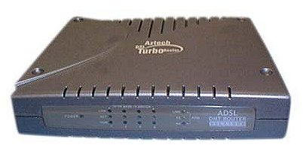
\ \
DSL305E
Internet

Figure 1.1: Network Setup

1.4 Physical Layer and Hardware
Requirement |  | Result | Description
1.4.1 | Ethernet with Full Duplex | Pass  *10/100Mbps auto selection | The modem must have at least one 10BaseT Full Duplex Ethernet port.
1.4.2 | Auto-sensing Ethernet wiring | Not supported | The user may apply a crossed or a non-crossed Ethernet cable without notice.
1.4.3 | Auto-sensing ADSL wiring | Not supported | The user may apply a RJ-11 cable using either the pair on pins 3&4 or the pair on pins 2&5 for the ADSL signal without notice.
1.4.4 | Power On/Off Switch | Not Applicable | The modem must have a power on/off switch.
1.4.5 | Reset-to-Factory Default button | Pass | With a simple method it must be possible to reset the modem configuration to its factory default setting. The preferred method is to apply a power cycle while holding a reset button for at least 5 seconds.
1.4.6 | No Audible Noise | Pass | During normal operation, the level of audible noise level should be negligible and meet standards as for devices used in silent household environments.

1.5 Firmware Requirements
Requirement |  | Result | Description
1.5.1 | Dynamic Host Configuration Protocol (DHCP) Server | Not Applicable | - Ensure that the DHCP Server option in the router modem is enable. Other option such as NAT can be disable for the testing purpose at this state.  - Set the TCP/IP Properties option in the Network applet under Control Panel windows with its <IP Address> tab set to “Obtain an IP address automatically” option.
1.5.2 | Network Address Translation (NAT) / Network Address Port Translation (NAPT) | Not Applicable
1.5.3 | PAP and CHAP Authentication Test (RFC 2364 and RFC2516) | Pass | - Connect to PPP server using PAP and CHAP authentication method.  - Make sure the PPP session is established and surf the Internet for a while.  - This feature is set in Auto-mode and is hidden from user.
1.5.4 | PVC Support | Pass
1.5.5 | Firmware updates | Pass | The modem firmware must be capable of being locally upgraded.
1.5.6 | Default IP address / SmartURL | Pass | The modem use 10.0.0.2 as IP address by factory default setting. User can also log in to modem using SmartURL command on the Internet Browser.
1.5.7 | OAMLOOPBACK F4/F5 with End-to-End or Segment-to-Segment | Pass  *Tested on F5 End-to-End | Using Web Interface, under Diagnostic Test
1.5.8 | IPSec Pass-Through | Unable to test | Please refer to Conexant.
1.5.9 | Multiple IPSec Pass-Through | Unable to test | Please refer to Conexant.

1.6 Management Requirements
Requirement |  | Result | Description
1.6.1 | PPP User ID and Password | Pass | The PPP User ID and Password will saved to the flash.
1.6.2 | Admin User ID and Password | Not Applicable | The Admin User ID and Password must be clearly specified the access right.
1.6.3 | Utility for collecting traffic statistics | Pass  *Under Web Interface, Connection Status | Check whether the Status shows the traffic statistics on the WAN interface.
1.6.4 | Remote Access Enable / Disable | Not Applicable | The modem must allow the user to turn on/off all remote access.
1.6.5 | Diagnostic Test | Pass  *Under Web Interface, Diagnostic Test | Able to do a diagnostic test base on SingNet requirement.

1.7 PPP half bridge and Transparent bridge mode Test for DSL 305E
Test Title |  | Win98SE | WinME | Win2000 | WinXP | Test Procedure
1.7.1 | PPP Half bridge | Pass | Pass | Pass | Pass | When connected to ISP in this mode, must be able to surf the Internet. User must enter the user login name and password at Quick Start.
1.7.2 | Transparent bridge mode | Pass | Pass | Pass | Pass | When connected to ISP in this mode, must be able to surf the Internet. User must need WinPoET or equivalent software to log in to ISP.

1.8 Gaming test
Test Title |  | Win98SE | WinME | Win2000 | WinXP | Test Procedure
1.8.1 | StarCraft | Not Tested | Not Tested | Not Tested | Not Tested | The gaming can be conducted with Internet Players
1.8.2 | Half-Life | Pass | Pass | Pass | Pass | The gaming can be conducted with Internet Players

For game tests, the TEST would failed if:
- The gaming party using ADSL disconnect repeatedly
- One of the gaming parties cannot connect to same game server

Note: The test is done only in PPP half-bridge mode. Transparent bridge mode is still under test.

1.9 Application Test
Test Title |  | Win98SE | WinME | Win2000 | WinXP | Test Procedure
1.9.1 | Netmeeting | Pass | Pass | Pass | Pass | Setup the Netmeeting on local PC, and try to make a call to remote PC. See whether the connection can be established, or local PC is able to view remote PC or not.
1.9.2 | ICQ | Pass | Pass | Pass | Pass | Must be able to log in to ICQ server.
1.9.3 | mIRC | Pass | Pass | Pass | Pass | Must be able to join in to a chat room.
1.9.4 | Microsoft Messenger | Pass | Pass | Pass | Pass | Must be able to log in to Microsoft Messenger server.
1.9.5 | FTP download | Pass | Pass | Pass | Pass | Must be able to log in to local and oversea FTP server and download / upload files.
1.9.6 | Http download | Pass | Pass | Pass | Pass | Must be able to download files from local and oversea websites.
1.9.7 | Video Streaming | Pass | Pass | Pass | Pass | Must be able to watch video streaming from local and oversea websites.

For the above tests, the TEST would fail if:
- The connection can’t be established at all
- Cannot receive and sent files (for Netmeeting, ICQ, mIRC, Microsoft Messenger and FTP)
- Cannot receive and sent message (for Netmeeting, ICQ, mIRC, Microsoft Messenger)
Note: The test is done only in PPP half-bridge mode. Transparent bridge mode is still under test.
2 Performance Test

2.1 FTP & Audio/Video Streaming Test on PPP over ATM (RFC 2364) against
SingNet Broadband

- FTP – using WS_FTP LE version 5.08
- Audio/Video streaming - using Windows Media Player v7.0

Test Title | Win98SE |  | Test Procedure
Test Title | Ethernet | USB | Test Procedure
FTP test | PASS  Upload speed : 25.9 KB/S  Download speed : 19.47 KB/S  Subscribed Bandwidth: 512 Kbps Downstream, 256Kbps Upstream | PASS  Upload speed : 21.3 KB/S  Download speed : 17.43 KB/S  Subscribed Bandwidth: 512 Kbps Downstream, 256Kbps Upstream | - Go to oversea website : www.download.com, and download a >20MB file.  - Go to local website : ftp.aztech.com.sg, and upload a >20MB file.
Streaming Audio and Video | PASS  Tested for : 10 mins  Downstream : 3488 Kbps Upstream : 448 Kbps  Actual rate : 14.02  Transmission protocol : Unicast TCP  Bandwidth : 203 Kbps  Total received packet : 6440  Total bad packet : 0 | PASS  Tested for : 10 mins  Downstream : 3488 Kbps Upstream : 448 Kbps  Actual rate : 14.30  Transmission protocol : Unicast TCP  Bandwidth : 204 Kbps  Total received packet : 6540  Total bad packet : 0 | Go to local website: www.channelnewsasia.com for this test.

Test Title | WinME |  | Test Procedure
Test Title | Ethernet | USB | Test Procedure
FTP test | PASS  Upload speed : 26.52 KB/S  Download speed : 11.7 KB/S  Subscribed Bandwidth: 512 Kbps Downstream, 256Kbps Upstream | PASS  Upload speed : 21.3 KB/S  Download speed : 17.43 KB/S  Subscribed Bandwidth: 512 Kbps Downstream, 256Kbps Upstream | - Go to oversea website : www.download.com, and download a >20MB file.  - Go to local website : ftp.aztech.com.sg, and upload a >20MB file.
Streaming Audio and Video | PASS  Tested for : 10 mins  Downstream : 3488 Kbps Upstream : 448 Kbps  Actual rate : 14.1  Transmission protocol : Unicast TCP  Bandwidth : 204 Kbps  Total received packet : 6413  Total bad packet : 0 | PASS  Tested for : 10 mins  Downstream : 3488 Kbps Upstream : 448 Kbps  Actual rate : 14.36  Transmission protocol : Unicast TCP  Bandwidth : 204 Kbps  Total received packet : 6212  Total bad packet : 0 | Go to local website: www.channelnewsasia.com for this test.

Test Title | Win2000 |  | Test Procedure
Test Title | Ethernet | USB | Test Procedure
FTP test | PASS  Upload speed : 26.52 KB/S  Download speed : 11.5 KB/S  Subscribed Bandwidth: 512 Kbps Downstream, 256Kbps Upstream | PASS  Upload speed : 25.95 KB/S  Download speed : 11.7 KB/S  Subscribed Bandwidth: 512 Kbps Downstream, 256Kbps Upstream | - Go to oversea website : www.download.com, and download a >20MB file.  - Go to local website : ftp.aztech.com.sg, and upload a >20MB file.
Streaming Audio and Video | PASS  Tested for : 10 mins  Downstream : 3488 Kbps Upstream : 448 Kbps  Actual rate : 14.52  Transmission protocol : Unicast TCP  Bandwidth : 204 Kbps  Total received packet : 6218  Total bad packet : 0 | PASS  Tested for : 10 mins  Downstream : 3488 Kbps Upstream : 448 Kbps  Actual rate : 14.48  Transmission protocol : Unicast TCP  Bandwidth : 204 Kbps  Total received packet : 6208  Total bad packet : 0 | Go to local website: www.channelnewsasia.com for this test.

Test Title | WinXP |  | Test Procedure
Test Title | Ethernet | USB | Test Procedure
FTP test | PASS  Upload speed : 24.34 KB/S  Download speed : 11.08 KB/S  Subscribed Bandwidth: 512 Kbps Downstream, 256Kbps Upstream | PASS  Upload speed : 23.84 KB/S  Download speed : 12.46 KB/S  Subscribed Bandwidth: 512 Kbps Downstream, 256Kbps Upstream | - Go to oversea website : www.download.com, and download a >20MB file.  - Go to local website : ftp.aztech.com.sg, and upload a >20MB file.
Streaming Audio and Video | PASS  Tested for : 10 mins  Downstream : 3488 Kbps Upstream : 448 Kbps  Actual rate : 14.06  Transmission protocol : Unicast TCP  Bandwidth : 204 Kbps  Total received packet : 6470  Total bad packet : 0 | PASS  Tested for : 10 mins  Downstream : 3488 Kbps Upstream : 448 Kbps  Actual rate : 14.61  Transmission protocol : Unicast TCP  Bandwidth : 204 Kbps  Total received packet : 6208  Total bad packet : 0 | Go to local website: www.channelnewsasia.com for this test.

3 Appendix
3.1 Technology of PPP Half-Bridge mode

Conexant has come out with this technology of PPP Half-Bridge mode. Take a look at the following figures:

Common ADSL Modem
ISP Server
Internet
Using Dialer to dial to ISP. Some common dialer like WinPoET, Microsoft Dial-up, etc.

Figure 3.1.1 – Common way to dial to ISP

As can see from the above figure 2.1.1, the PC initiates the dialing process. PC must install certain dialer such as WinPoET or Microsoft Dial-up to initiates the dialing process.

DSL305E ADSL Modem
ISP Server
Internet
No need dialer as dialing is initiated at ADSL modem. Just save User ID and Password in modem.

Figure 3.1.2 – PPP Half-bridge modem

In figure 2.1.2, the DSL305E ADSL initiates the dialing process. PC does not require any dialer software. Open up web browser and save the User ID and Password in the modem. Once User ID and Password is saved, the modem will automatically connect to ISP. Click ‘Disconnect’ in the ‘Connection Status’ to disconnect from ISP. (refer to Manual on how to access the modem with web browser)

The Advantages and Disadvantages of PPP Half-bridge.
Advantages
- No installation of software is required thus saving cost.
Disadvantages
- PPP half-bridge mode will take some time for the WAN IP address to transfer to the PC (about 1 min). User will sometime experience ‘Page cannot display’ on the browser (when the process of connecting to ISP).

3.2 Screen Shots
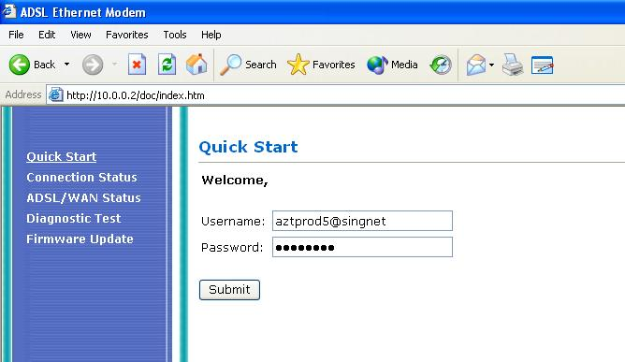

Figure 3.2.1 Quick Start Page

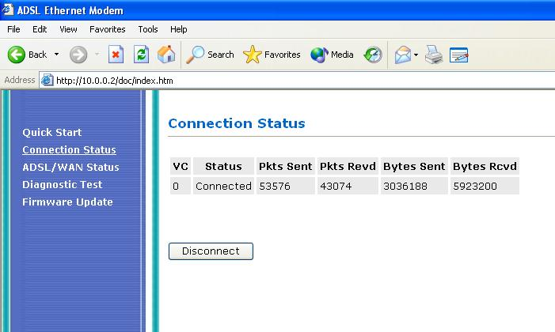

Figure 3.2.2 Connection Status Page

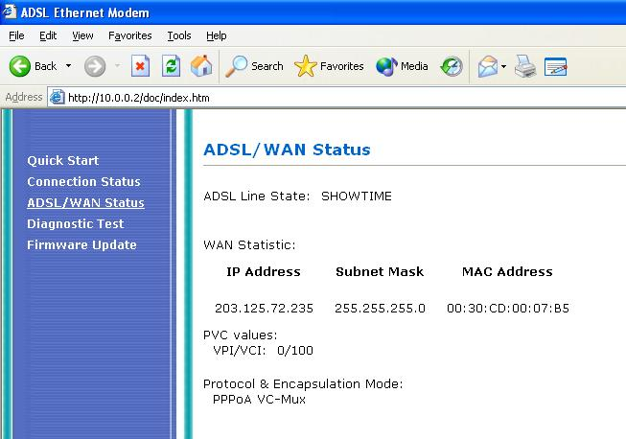

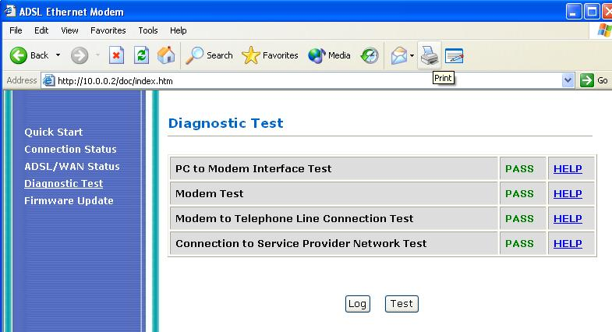
Figure 3.2.3 ADSL/WAN Status Page

Figure 3.2.4 Diagnostic Test

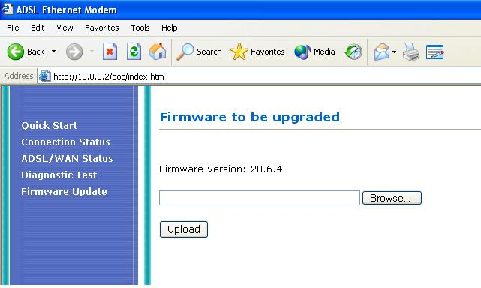
Figure 3.2.5 Firmware Update Page

3.3 Updating Firmware

- To update the firmware, click on the link, ‘Firmware Update’ to go to the Firmware Update page (Figure 2.2.5).
- Click on the Browse button to select the ‘firmware.dlf’ file.
- Click Upload button to upload the firmware file to the flash memory.
- The file will upload and restart the modem to upgrade/downgrade firmware of the modem.

3.4 SmartURL command

This modem comes with SmartURL command features. User can easily log in to the modem by typing SmartURL command in the Browser’s Address field.

These are the commands:
- startmodem - To go to the ‘Quick Start’ page.
- login - To go to ‘Log in’ page.
- logout - To log out of ISP.
- ppp - To go to ‘Connection Status’ page.
- diagnostics - To go to ‘Diagnostic Test’ page.
- syslog - To go to ‘System Log’ page.
- connectrouter- To set the modem to transparent bridge mode. Once in this
mode, you will not able to log in to the modem. Hard reset the
modem to set it back to default factory mode.

3.5 Connecting to ISP

To connect to ISP is simple. Enter the login name and password at the ‘Quick Start’ page (Figure 2.2.1). Click Submit button to save and connect to ISP. This may take up to 1 min to connect to ISP due to negotiation between ISP to PC in half-bridge mode.

3.6 Gaming test

This section tests the modem whether is it able to connect to Game servers or play Internet Game. The game running on this modem is Half-life with latest update of version 1110. The test is conduct in this way:

- Connect to ISP. (SingNet Broadband)
- Run Half-life.
- Go to Multi-player and select Internet.
- Select any server. It is advisable to connect to a high-speed low latency server.
- Play the game.

The test results are shown on section 1.8.

3.7 Netmeeting test

This section tests the modem whether is it able to run the Netmeeting and stream video and voice data to another remote user.
Internet
DSL 305E
Netmeeting 1
Netmeeting 2

Figure 3.7.1 Netmeeting

Test done under Win98 SE, Win ME and Win 2000

- Connect to ISP. (SingNet Broadband)
- Start Microsoft Messenger. You may need to register a hotmail account.
- Using Microsoft Messenger, start a Netmeeting session with another party.
- Check whether the other party can able to communicate with you.
- Check the Video streaming and Voice streaming.

Test done under Win XP

- Connect to ISP. (SingNet Broadband)
- Start and Configure Netmeeting session.
- If you are able to log in to the Microsoft Internet Directory Server, you may find another party to have a Netmeeting session with you. Please note that Microsoft Internet Directory is not maintained, you may need to find other ILS server. Please go to www.meetingbywire.com/NetMeeting101.htm for more information.
- If not you have to key in the WAN IP address of the other party in the ‘Address field’.
- Check whether the other party can able to communicate with you.
- Check the Video streaming and Voice streaming.

The test results are shown on section 1.9.

3.8 Transparent Bridge Mode

Theoretical, user can connect the DSL305E (in transparent bridge mode) to a broadband router to share the Internet connection to multiple PCs.


Internet
DSL305E in transparent bridge mode
Broadband Router

Figure 3.8.1 Sharing Internet Connection using DSL305E in transparent bridge mode

To set DSL305E to transparent bridge mode, key in the connectrouter command in the Browser’s Address field.

